DLD LAB 06:

Q4:

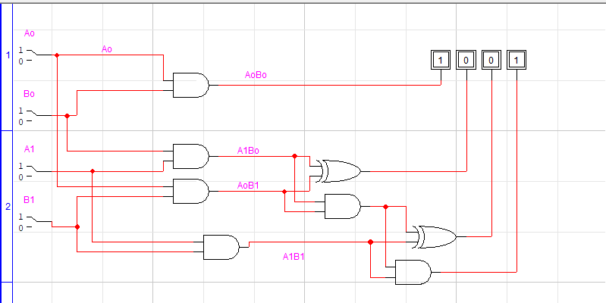

TruthTable:

|  |  |  |  |  |  |  |  |  |  |  |
| --- | --- | --- | --- | --- | --- | --- | --- | --- | --- | --- |
| A1 | Ao | B1 | Bo | A1Bo | AoB1 | A1B1 | AoB1+A1Bo | C | A1B1+C | AoBo |
| 0 | 0 | 0 | 0 | 0 | 0 | 0 | 0 | 0 | 0 | 0 |
| 0 | 0 | 0 | 1 | 0 | 0 | 0 | 0 | 0 | 0 | 0 |
| 0 | 0 | 1 | 0 | 0 | 0 | 0 | 0 | 0 | 0 | 0 |
| 0 | 0 | 1 | 1 | 0 | 0 | 0 | 0 | 0 | 0 | 0 |
| 0 | 1 | 0 | 0 | 0 | 0 | 0 | 0 | 0 | 0 | 0 |
| 0 | 1 | 0 | 1 | 0 | 0 | 0 | 0 | 0 | 0 | 1 |
| 0 | 1 | 1 | 0 | 0 | 1 | 0 | 1 | 0 | 0 | 0 |
| 0 | 1 | 1 | 1 | 0 | 1 | 0 | 1 | 0 | 0 | 1 |
| 1 | 0 | 0 | 0 | 0 | 0 | 0 | 0 | 0 | 0 | 0 |
| 1 | 0 | 0 | 1 | 1 | 0 | 0 | 1 | 0 | 0 | 0 |
| 1 | 0 | 1 | 0 | 0 | 0 | 1 | 0 | 0 | 1 | 0 |
| 1 | 0 | 1 | 1 | 1 | 0 | 1 | 1 | 0 | 1 | 0 |
| 1 | 1 | 0 | 0 | 0 | 0 | 0 | 0 | 0 | 0 | 0 |
| 1 | 1 | 0 | 1 | 1 | 0 | 0 | 1 | 0 | 0 | 1 |
| 1 | 1 | 1 | 0 | 0 | 1 | 1 | 1 | 0 | 1 | 0 |
| 1 | 1 | 1 | 1 | 1 | 1 | 1 | 1 | 1 | 1 | 1 |

Q5:

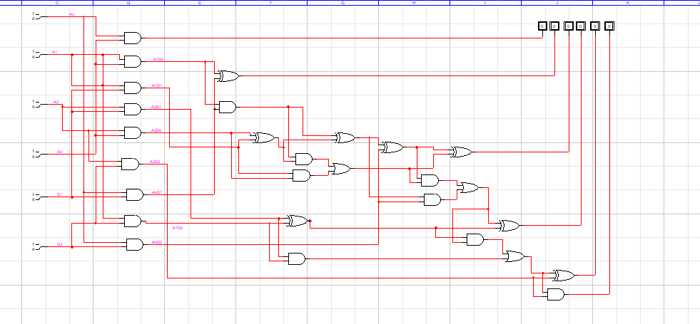

Q6:

4-bit Adder:

